Manoj kumar SV -24PG00183

Shilpa shree V -24PG00189

# COLLEGE NIRF RANK PREDICTION USING MACHINELEARNING



**ABSTRACT:**College NIRF rank prediction isuseful for predicting the NIRF rankings of the institutes in India.The National Institutional Ranking Framework (NIRF) [1] was approved by the MHRD and the rankings are release devery year by the Honourable Minister of HumanResource Development reflecting the performances of various institutes in India. This study uses the power of machine learning algorithms topredict the NIRF rank of the institute based on their score in several features. There are numerous features on which the rankings are released these features are majorly categorized into five parameters(TLR,Resea rch,GO,PI,Outreach). Predicting NIRF rank will not only help students in their institute selectionprocess but also helps the institute identify their weak areas so that they can improve in those areas. Our study not only predicts the NIRF rank of the institute but also helps the institute to compare their scores with the top institute by entering the rank of the institute with which they want to compare.Predicting NIRF rank can be understood as a regression problem where the rank is the output , there are several regression algorithms such as Linear Regression , Decision Tree , Random forest etc , by using various metrics such as RMSE(rootmeansquareerror),mean square error etc we can select effective algorithm.Using flask server

/Django we have converted the side a into an application with simpleuser interface.

**Keywords:**NIRF,machinelearning,RMSE,Flaskserver,RandomForest,Linearregression,DecisionTree.

## 2.REVIEWOFLITERATURE

Machine learning algorithms have been widely studied and used in various domains of education. Dr . Bishnuprasad mishra and Dr. Banashri Rath [1]proposed a machine learning technique to find thecorrect weight-agefor the best result . Nidhi Agarwal and Devendra Tayal [2] proposeda new way to predict how well universitiesand colleges rank . Nishi Doshi, Samhitha Gundam and Bhaskar Chaudhury [3] discussed a method to help universities and higher educational institutes improve the irrankings using techniques like(EDA,DecisionsTreeset

c)AnikaTabassum,MahamudulHasanandShibbirAhmed[4]developedamodelwhichpredictstherankingsbyanalyzin g influential global performance indicators.AnuvaGoyal,PremPrakashVuppuluri[5]:"AnAnalyticalApproach

Towards the Prediction of Undefined Parameters for the National Institutional Ranking Framework"explores a method to predict undefined parameters in the National Institutional Ranking Framework (NIRF) for Higher Education Institutions(HEI’s)inIndia .

## 3.METHODOLOGY

The methodology for predicting the NIRF rank comprises of several important steps . At first data is collected from various sources(we have taken the dataset from kaggle)such as kaggle,etc.The collected data will then undergo severe pre-processing to remove the inconsistencies from data to makeit suitable for analysis.The sub sequent step involves selection of features which can be done with the help of principal componentana lysis(PCA), wehavetaken 5featuresinoursystem.

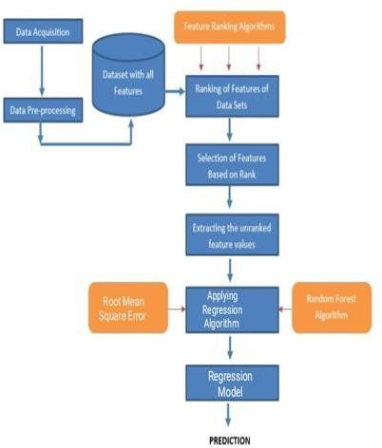

**Figure1.**Methodology

Afterselection of the featuresthe dataset is partitioned into training dataset and testing dataset . The nextstep is model developmentwhich involves selection of proper machinelearning algorithm. As NIRF rank prediction is a regression problem where the output is the rank we have to select proper regression algorithm using some parametric measures such as(RMSE,MSE)

etc. We have tested some major regression algorithms and selected random forest algorithm due its lower RMSE value.L ower the RMSE value more is the accuracy.

## 4.EXISTINGSYSTEMVSPROPOSEDSYSTEM

There are several existing systems to predict the NIRF rank of the institutes in one of the Journal of machinelearning research the authors came up with an idea of combining both Machine learning algorithms and SNA (Social Network Analysis ) . In this paper Research productivity , Teaching effectiveness etc. are some of theparameters taken into consideration for predicting the NIRF rank . Another study in the journal of appliedresearchused DEA ( data envelopment analysis ) to predict the NIRF rank . This study used parameters such asinfrastructure , qualityofthefacultyetc.

In the study published in journal of Data Science the authors used machine learning algorithmssuch asgradientboostingtopredictthe NIRFrank parameters usedare perception,research.

The proposed System to predict the NIRF rank of the institute uses a suitable machine learningalgorithmtopredict the NIRF rank based on the overall score obtained from the 5 parameters. At its core the system wouldbegin from data collection from various sources . This data will then undergo rigorous preprocessing to makethe data suitable for training and testing the model. The algorithm used by the proposed system is Randomforest regression algorithm which is having lower RMSE ( root mean square error ) among all the

regressionalgorithmsaftertestingwithsampledata.Apart from predicting the nirf rank,we also incorporated a innovat ivefeature allowing the institutes to compare their parametric scores with the institute of their desired rank . Onentering the rank of their desired institute institutes can access the comparisons of all 5 parameters which are shown in the form of graphs using plotl ylibrary.

## 5.RESULTS

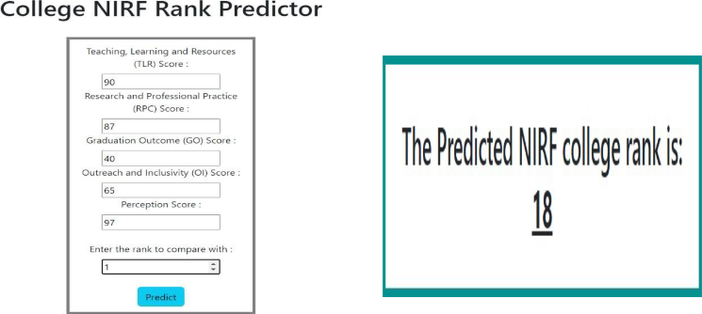

**Figure2.** Post-InputFormPicture **Figure3.**Outcomeofformsubmission

Now enter l the scores ofthe institution top redictit’s NIRF ranking,alsoenter the NIRF rank of the institution tocompare:

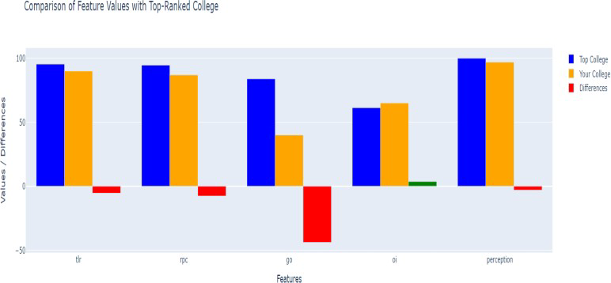

Figure4.Comparison of feature values with aspecifiedrankforanalysis

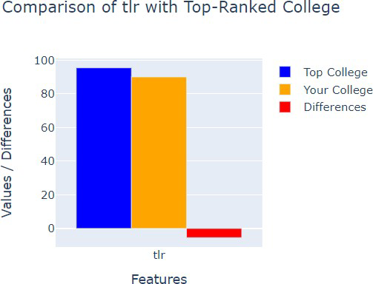

Figure5.ComparisonofTLR-Teaching,LearningandResources

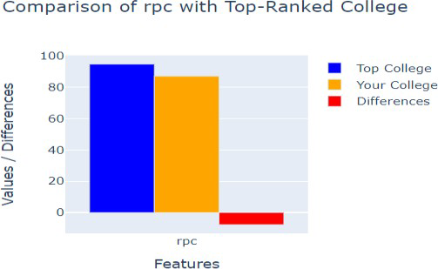

Figure6.ComparisonofRPC-ResearchandProfessional Practices

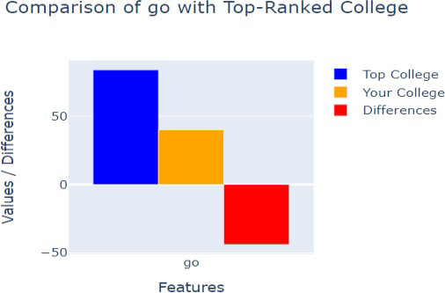

Figure7.ComparisonofGO-GraduationOutcome

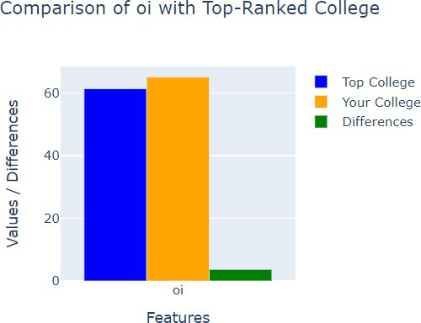

Figure8.ComparisonofOI-OutreachandInclusivity.

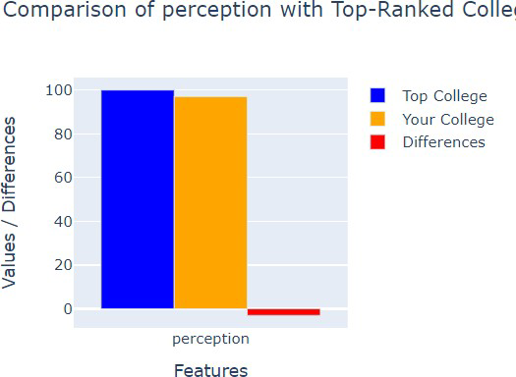

Figure9.ComparisonofPerception

## 6.CONCLUSION

In conclusion this study represents an important application of machinelearning algorithms inprediction of NIRF rank of the institutes in India. The NIRF rank prediction not only assists the students in selection of institute butalso helps the institute to identify their weak areas and also provides an insights intoperformance of the institutes to assist policy makers in decisionmaking.Also in this paper we have introduced a new feature allowing the institutes to compare their scores with other institutes .Among the various machine learning algorithms wefound out the Random forest regression has lower root mean square value (13.9)among all other regressionalgorithms. Currently the model has been built with limited features, apparently in future there will moreparameters to be incorporated into the model. As the performance of the institute will vary from year to yearthe model needs tobe continuously monitored.

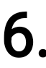

## REFERENCES

1. Dr.BishnuPrasadMishraandDr.BanashriRath:"MLUseForForecastingTheNIRFRankingOfEngineeringColleges InIndia AndPCAToFindThe CorrectWeightageFor TheBestResult".

1. NidhiAgarwalandDevendraK.Tayal:"FFTBasedEnsembledModeltoPredictRanksofHigherEducationalInstitution s".

1. Nishi Doshi, Samhitha Gundam and Bhaskar Chaudhury: "Strategizing University RankImprovement usingInterpretableMachineLearningandDataVisualization".

1. Anika Tabassum, Mahamudul Hasan and Shibbir Ahmed: "University Ranking Prediction System by AnalyzingInfluentialGlobalPerformanceIndicators".

1. AnuvaGoyal,PremPrakashVuppuluri[5]:"AnAnalyticalApproachTowardsthePredictionofUndefinedParametersfortheNa tional Institutional RankingFramework"